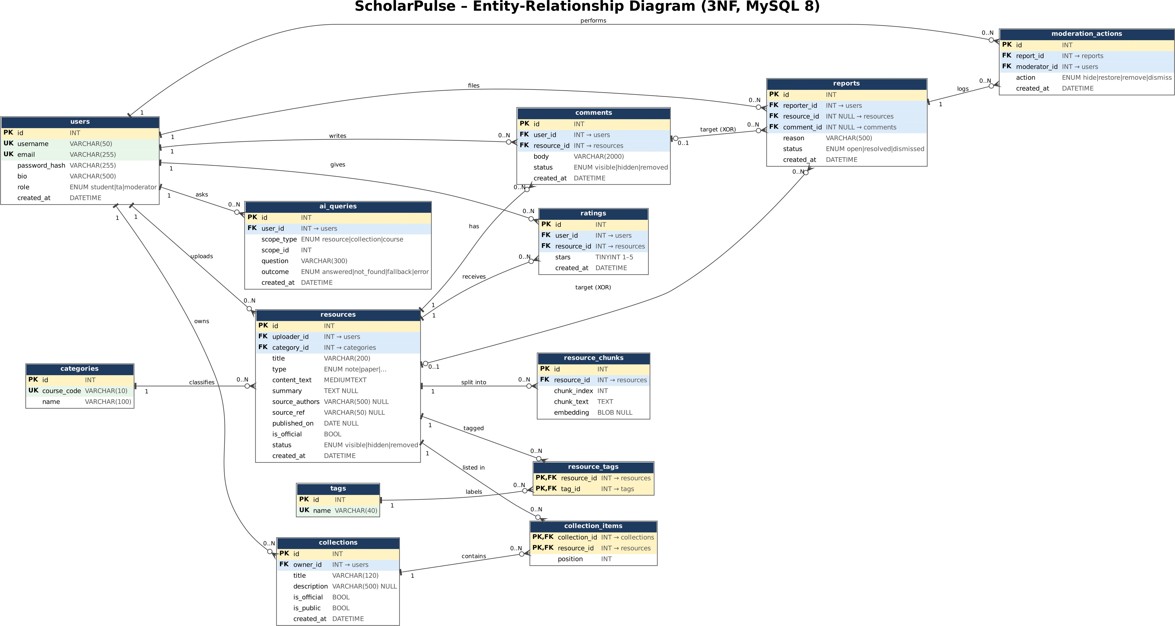

ScholarPulse – ER diagram notes (MS-2)
Team: Harshit Pant (cs26mt006), Gangadevi Venkata Siva (cs26mt009), Snehadip Ghoshal (cs26mt010). Schema: MySQL 8 / InnoDB, managed by SQLAlchemy + Alembic. Page 1 is the diagram; legend: PK primary key, FK foreign key, UK unique. Crow's foot = many, bar = exactly one, circle = optional.

Cardinalities

Relationship | Cardinality | Notes
users – resources | 1 : 0..N | Every resource has exactly one uploader (seeded papers use a system user).
categories – resources | 1 : 0..N | A category is a course code (CS301, CS402, CS205, SE101); each resource belongs to one.
resources – resource_chunks | 1 : 0..N | Chunks are deleted with their resource (ON DELETE CASCADE); UNIQUE(resource_id, chunk_index).
resources – tags | M : N | Resolved by resource_tags with composite PK (resource_id, tag_id).
users – ratings – resources | 1:0..N and 1:0..N | A user rates a resource at most once: UNIQUE(user_id, resource_id).
users / resources – comments | 1 : 0..N each | Comment belongs to one author and one resource.
users – collections | 1 : 0..N | Owner. Only TAs may set is_official (enforced in the API).
collections – resources | M : N | Resolved by collection_items; position gives the order; UNIQUE(collection_id, position).
users – reports | 1 : 0..N | Reporter. Each report targets exactly one of resource_id or comment_id (CHECK, XOR).
resources / comments – reports | 0..1 : 0..N | The other FK is NULL.
reports – moderation_actions | 1 : 0..N | Hide, restore, remove, dismiss; one row per action (the audit log).
users – moderation_actions | 1 : 0..N | The moderator who acted.
users – ai_queries | 1 : 0..N | Used for the 20-questions-per-hour limit and as an audit trail.

Why this is in third normal form
  - Every non-key column depends on the key, the whole key and nothing but the key. Course name and code live only in categories; resources store category_id, not a copy. Tag names live once in tags. Both many-to-many links are separate tables, so no column holds a list.
  - Derived values are not stored. Average rating, rating count and comment count are computed from ratings and comments. If Explore sorting by rating is too slow with ~800 ratings (unlikely), a cached column can be added deliberately and documented.
  - Composite keys. resource_tags and collection_items have PK(resource_id, tag_id) and PK(collection_id, resource_id); their only non-key column (position) depends on the full key.
  - Known, deliberate compromises (stated so they are not mistaken for mistakes): (a) resources.source_authors is one text string. Authors are not platform users, are only displayed and never queried or joined, so it is treated as an atomic display value; if author search is later needed it would become an authors table. (b) ai_queries.scope_id points at a resource, collection or category depending on scope_type, so the database cannot enforce it as a foreign key; the API validates it. (c) reports.status repeats what the latest moderation action implies; it is kept so the open-reports queue is a single indexed lookup, and it is updated in the same transaction as the action.

Change from MS-1
MS-1 planned 12 tables. This diagram has 13: moderation_actions is new. MS-1 says every moderation action is logged and moderators can restore hidden items; a single status column on reports cannot record who did what and when, or a hide followed by a restore. The page-1 diagram uses the name categories for courses, as in MS-1.

Indexes we expect to need
Primary keys and the unique constraints below are indexed automatically; InnoDB also indexes foreign keys, but we list the composite indexes explicitly because they match real queries. The queries come from the page list in MS-1. At ~630 resources and a few thousand chunks everything is fast even unindexed, so these are chosen for correctness (uniqueness) and to show query-driven design; we will confirm with EXPLAIN in MS-3.
Table | Index | Query it serves
users | UNIQUE(username), UNIQUE(email) | Login lookup by email; duplicate prevention at signup.
categories | UNIQUE(course_code) | Course filter and course-scope AI question.
resources | INDEX(category_id, status, created_at) | Explore filtered by course, visible only, newest first.
resources | INDEX(is_official, status, created_at) | Home page: official and newest resources.
resources | INDEX(uploader_id) | Profile: my uploads.
resources | FULLTEXT(title) | Keyword search in Explore.
resource_chunks | UNIQUE(resource_id, chunk_index) | Load a resource's chunks in order; prevent duplicates. Also serves the AI scope query (all chunks of a resource).
resource_chunks | FULLTEXT(chunk_text) | Keyword baseline and the AI fallback (matching passages).
resource_tags | PK(resource_id, tag_id), INDEX(tag_id, resource_id) | Tags of a resource; resources with a tag.
ratings | UNIQUE(user_id, resource_id), INDEX(resource_id) | One rating per user; average rating of a resource.
comments | INDEX(resource_id, status, created_at) | Comments on a resource page; comment-count sort.
collections | INDEX(owner_id), INDEX(is_public, is_official) | Profile lists; public hub with official lists first.
collection_items | PK(collection_id, resource_id), UNIQUE(collection_id, position), INDEX(resource_id) | Ordered items of a list; which lists contain a resource.
reports | INDEX(status, created_at) | Moderation queue (open reports, oldest first).
reports | INDEX(resource_id), INDEX(comment_id) | Reports against an item.
moderation_actions | INDEX(report_id), INDEX(moderator_id) | Action history of a report; moderator's actions.
ai_queries | INDEX(user_id, created_at) | Count a user's questions in the last hour (rate limit).
Deliberately not indexed: role and status on their own (very few distinct values, so the optimiser would ignore them); content_text and embedding (large; embeddings are compared in application code, as decided in MS-1); free-text columns such as bio. Cost: each extra index slows writes slightly; with this write volume that is negligible.

Figma Links:
Flow 1: (Student logged in): https://www.figma.com/proto/J83qgyzZliIozmdjj9Vtg4/ScholarPulse-%E2%80%94-Complete-Prototype?node-id=2-2&starting-point-node-id=2%3A2&show-proto-sidebar=1
Flow 2(Sign in Log in page):
https://www.figma.com/proto/J83qgyzZliIozmdjj9Vtg4/ScholarPulse-%E2%80%94-Complete-Prototype?node-id=2-203&starting-point-node-id=2%3A203&show-proto-sidebar=1

